Star Pars

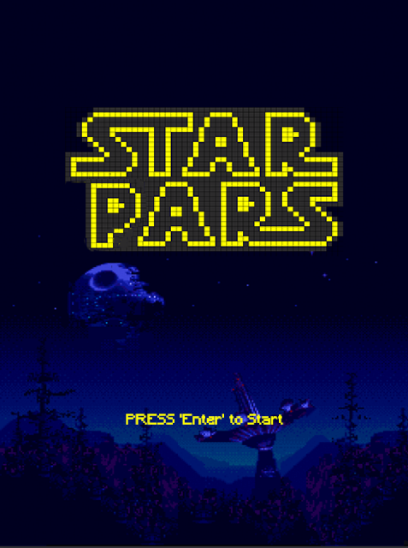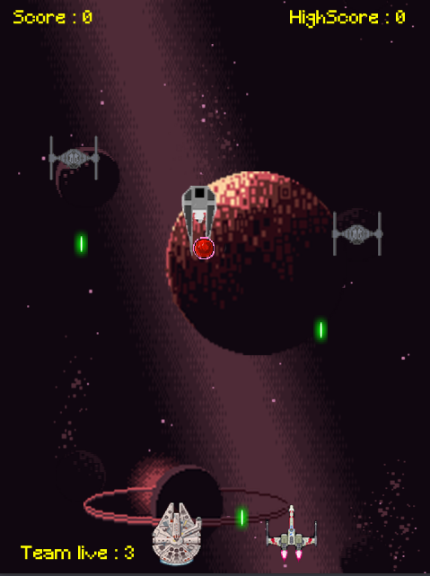

**Control Scheme**Player 1 Player 2   
W = up I = up   
S = down k = down

A = left j = left

D = Right L = right

Shoot = space bar shoot = m

**Gameplay rules**

Multiplayer mode is where both players share a team health of 3 and fight your way to get the highest score in an endless game. Single player mode is a Survival mode where the longer u survive the higher your score will be.   
  
**Game Objects**

|  |  |
| --- | --- |
| **Stuff Added** | **Purpose** |
| Palcon | Player 1 |
| Player 2 | Player 2 |
| Player beam | Player bullet |
| Beam 2 | Enemy bullet |
| Tie fighter | Enemy 1 |
| Power up | Power up bullets |
| Tie bomber | Enemy 2 |
| Bomb | Enemy 2’s bullets |
| Explosion 1 | Enemy 1 explosion |
| Explosion 2 | Enemy2 explosion |
| Title screen | Background |
| Option Screen | Background |
| Control scene | Background |
| Game over scene | Background |
| Bg 1 | Background |
| bg2 | Background for main game |
| bg3 | Background for main game |
| bg4 | Background for main game |
| Bg5 | Background for main game |
| gamefont | Front for game |
| Explosion fx | Explosion sound |
| Game BG music | Game background music |
| Game over music | Game over music |
| in game background music | In game background sound |
| Palcon sound | Player 1 shooting sound |
| Tie FX | Enemy shooting sound |
| Tie bomber sound | Tie bomber shooting sound |
| Ball collision 2 | Ball collide with paddle 2 |

**Gameplay Features**

Health system

* Added health system for both players in the game, giving them a total 3 team lives.

Time Counter   
- added a time counter for the single player mode. Where the time counter is being use to see how long can you survive in the gamemode

GameModes

- added 2 gamemode which are single and multiplayer. Multiplayer gamemode will have 2 players playing with a team life of 3, goal of the game is to get the highest score. Single player game mode is a survival gamemode where the player is scored by how long he can survive in the game by time counter, player is only given 1 life for this gamemode.

Power up pickups

* Added a power up where players can pick up this power up ingame to gain an additional bullet through the lifespan of the player. If the player dies he/she will lose the power up.

**Pseudocode**  
**Time counter**

When created

* Set timer to 0

Every N sec

* Do every 1 sec ( increment time by 1)

When updating

* If “time” is greater than “timescore”. Set “timescore” to “time”

**Health system**

In Actor behaviors

Collide with actor group

* When self hits an actor of “enemy”
* Set playerhealth to “playerhealth” minus 1

In scene events

When created

* Set player health to 3

When updating

* If player health is less than or equal to 0 switch scene to game over

**Power ups**

In behaviors

When player collides with power up

* Set “beamnumber” plus 1
* Kill power up actor

When updating

* Set beamspread to firing direction, beam speed and beam number
* Create beam at x and y of player in a repeat of “beamnumber” with the velocity of “firedirection” in degrees and speed of “beamspeed”

In scene behaviors

Every n Sec

* Create powerup at a random integer between 1 and 2 at a distance of 0 to 440 in x

In scene events

When created

* Set beam number to 1

**Game option**

When updating

* If 1 is down. Switch scene to controls scene for multiplayer mode
* If 2 is down. Switch scene to controls for singleplayer scene

**References**

1. Tie fighter art by Nicpng art

Link:<https://www.nicepng.com/maxp/u2q8q8q8o0t4y3w7/>

1. X wing art by dribble.com

Link:<https://www.pinterest.com/pin/417990409143952626/https://www.pinterest.com/pin/417990409143952626/>

1. Tie bomber bomb by Mr. Ken class resource
2. Power up art by Mr. Ken Class resource
3. Game over sound by Call of duty Modern Warfare 2 (Infinity Ward Studios)

Link: <https://www.youtube.com/watch?v=dwLCjZVEtpE&ab_channel=SathButtons>

1. Ingame music by john williams( the sith spacecraft and the droid battle)

Link: https://www.youtube.com/watch?v=u_mmm2CrCds

1. Title background sound by john williams ( Funeral pyre for a jedi)

Link: <https://www.youtube.com/watch?v=rtbhR7cjrBw>

1. Main game background explosion art and explosion sound by opengameart.org

Link: <https://opengameart.org/content/space-background-3>

1. Beams by Png AAA

Link:<https://www.pngaaa.com/detail/1819900>

1. Back ground by wallpaperlist.com

Link:<https://www.walpaperlist.com/2020/01/star-wars-wallpaper-gif-hd.html>

1. Palcon by imgur

Link: <https://www.pinterest.com/pin/813884963890724663/>

1. Beam sound by starwars

Link: <https://www.youtube.com/watch?v=Dav5kn_8BmY>